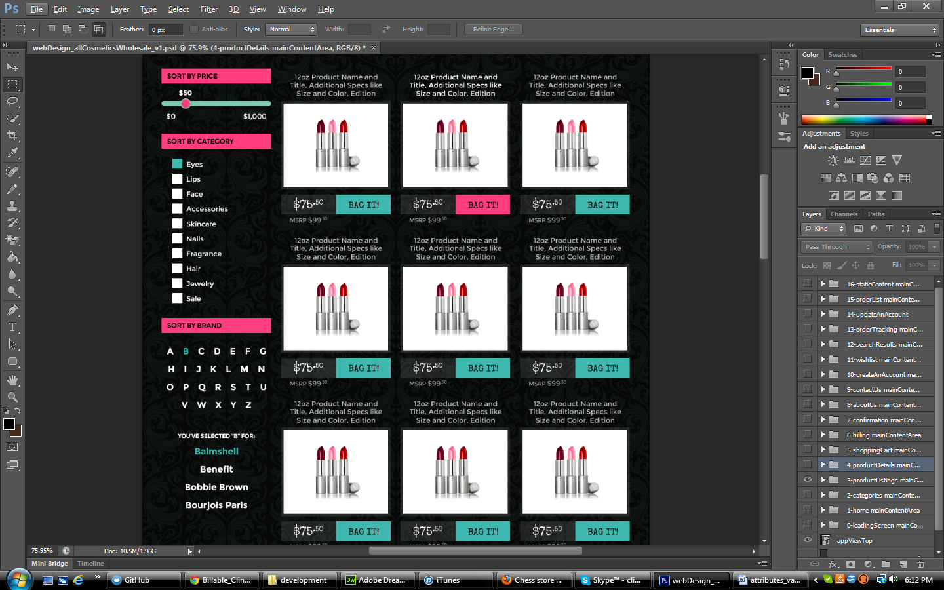

**ATTRIBUTE LIST:**

1. Category
2. Brand Letter
3. Brand Name

**REQUIRED VALUES FOR EACH CATEGORY:**

1. Category:
   1. eyes
   2. lips
   3. face
   4. accessories
   5. skincare
   6. nails
   7. fragrance
   8. hair
   9. jewelry
   10. sale
2. Brand Letter:
   1. A – Z
3. Brand Name:
   1. Will need an updated list of all active brands to be used as values.
   2. Because this section of the search is generated by selecting a brand alphabetically, will need to talk to Michael to discuss a way to dynamically generate this list of brand names. If not, will need to have a static list of brands associated with each brand letter and have to manually update the list whenever new brands are added/old brands removed.